# CST 338 – Spring 2016

# Project 2 (Part 3)

# Due: 05/13/2016 (11:55 PM)

# For the part 3 of the project2, you should develop an Android app for “Flight Reservation System for Otter Airways”. You can find the detailed description of the use case model at the part 2.

# At the end of the project, you have to submit two files on the iLearn.

# A ZIP file of your Android app: We do not accept other format such as tar or rar. If you do not submit a ZIP file, you will get zero for the part 3.

# This word file with test case execution results: For the grading purpose, we will use 15 test cases in this document. You have to run your app on your laptop before the submission and include execution result of each test case. As evidence of a passed test case, you have to include screenshot(s) of the test case to show that your app worked well on your laptop for the test case. If you do not include any screenshot for a test case, we will assume that your app doesn’t pass the test case.

====================== Summary of Test Case Execution Result ======================

**Note: You have to put “Pass” or “Fail” clearly at each “Result” cell.**

|  |  |
| --- | --- |
| **Test Case No** | **Result** |
| Test case 1 | Pass |
| Test case 2 | Pass |
| Test case 3 | Pass |
| Test case 4 | Pass |
| Test case 5 | Pass |
| Test case 6 | Pass |
| Test case 7 | Pass |
| Test case 8 | Pass |
| **Test Case No** | **Result** |
| Test case 9 | Pass |
| Test case 10 | Pass |
| Test case 11 | Pass |
| Test case 12 | Pass (Displays cancelation but not exact match to test case, please check) |
| Test case 13 | Pass |
| Test case 14 | Pass |
| Test case 15 | Pass |

======================== Test Cases for Project 2 (Part 3) ========================

# Note: You have to include screenshot(s) of each test case as evidence to show that your app works well on your laptop.

# Screenshots included below under their respective test case.

1. When your app starts, it should provide the main menu GUI with four options of “Create Account”, “Reserve Seat”, “Cancel Reservation”, and “Manage System”.

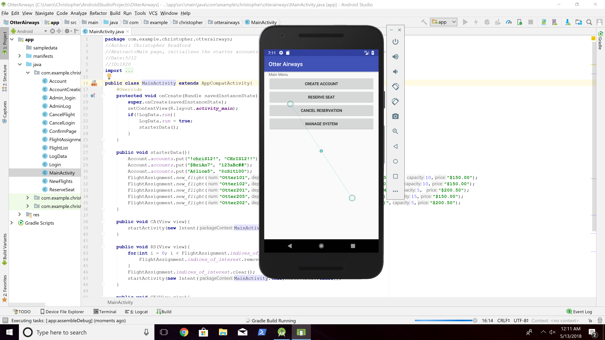

1. Create a correct account

- Select "Create Account"

- Username: !!Byun7

- Password: !!Byun7

🡺 The System informs the Customer that the new account has been created successfully.

After that, the System should display the main menu.

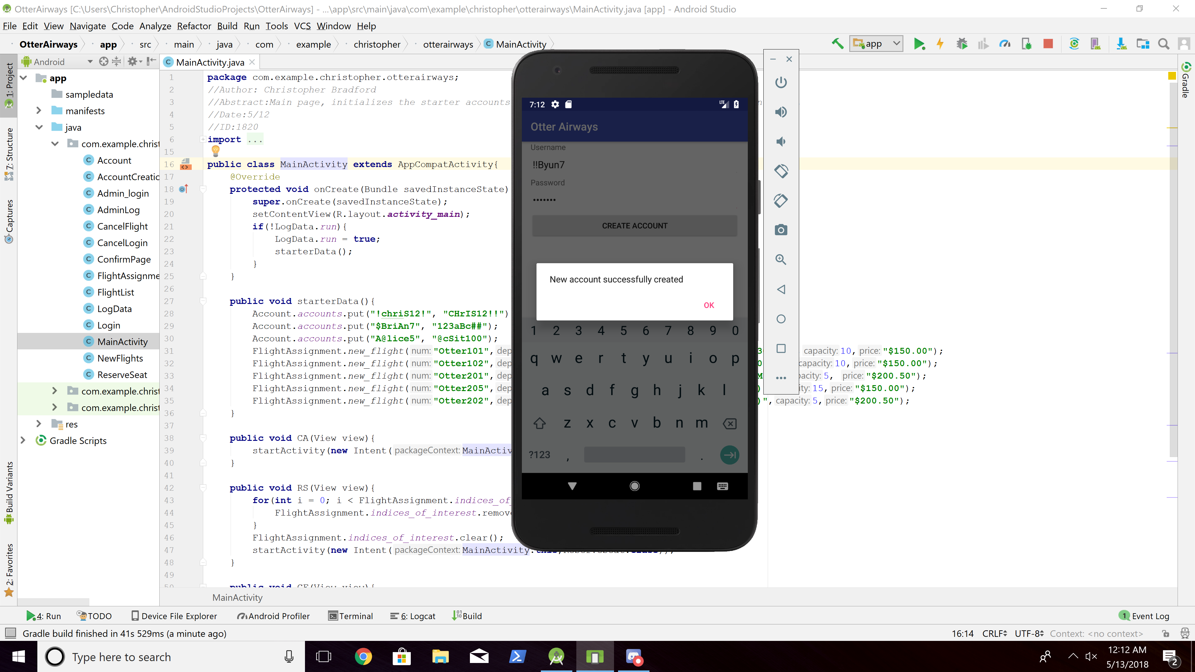

1. Manage the system - Verify the new account

- Select "Manage System"

- Username: !admiM2

- Password: !admiM2

🡺 The system should display

1. Transaction type: New account

2. Customer's username: !!Byun7

3. Transaction date: Depending on the test case 2 execution date.

4. Transaction time (= hour and minute): Depending on the test case 2 execution time.

- In this test case, the System Operator doesn’t add new flight information.

🡺 The System should display the main menu.

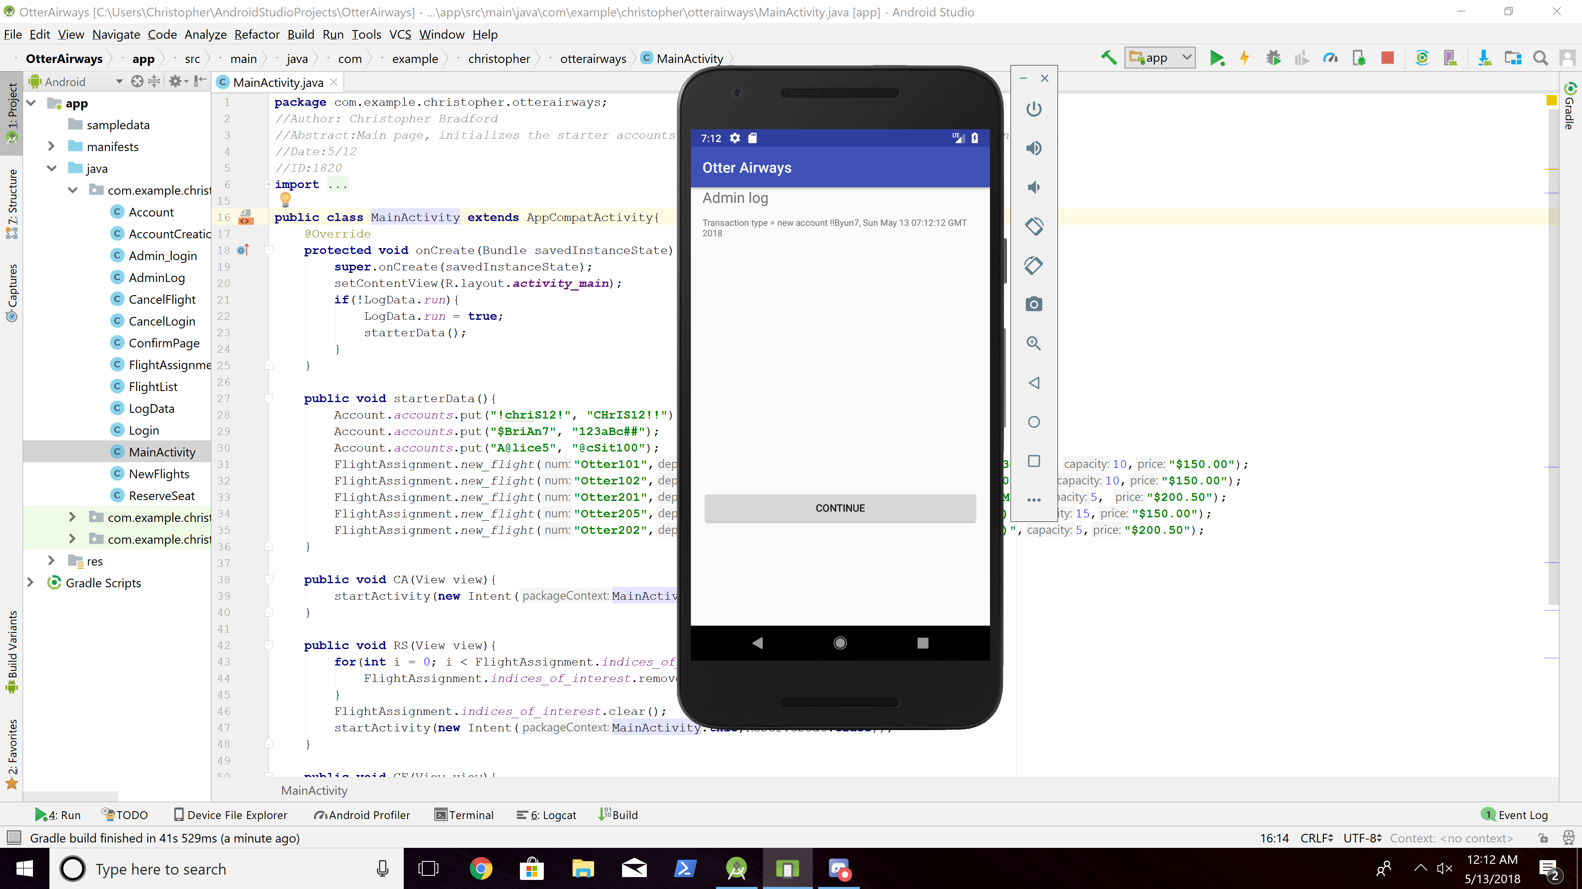

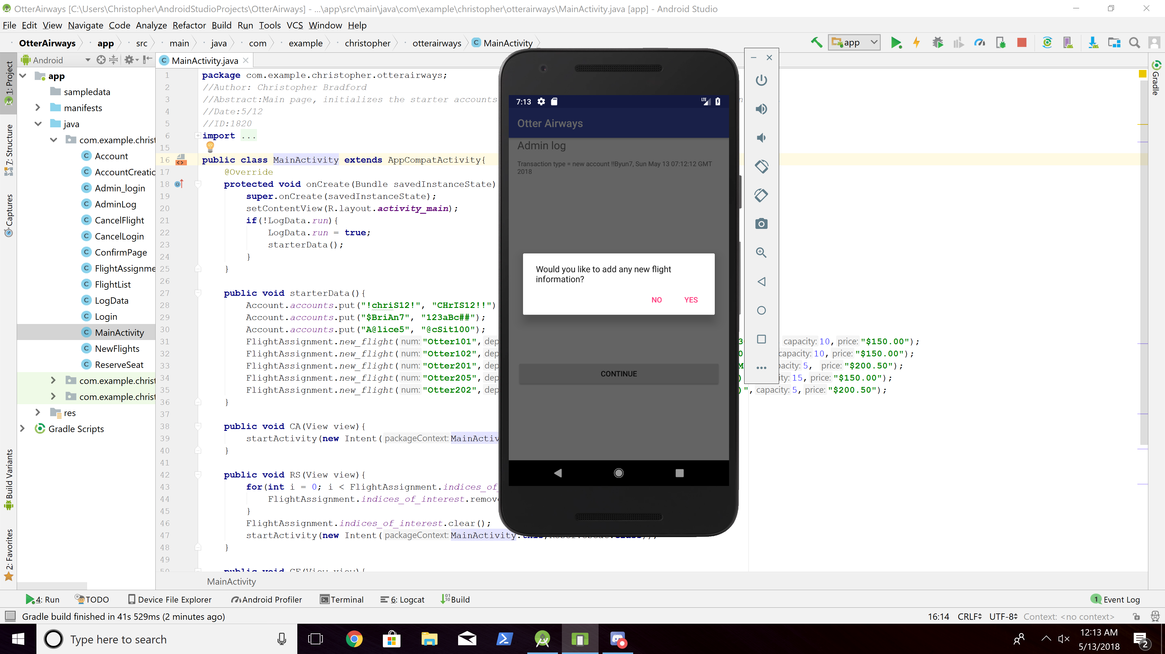

1. Create an incorrect account

- Select "Create Account"

- Username: byun7

- Password: !byun7

🡺 The System should display an error message.

- Username: byun7!

- Password: 7byun

🡺 The System should display an error message again.

The Customer confirms the error message.

Then, it displays the main menu.

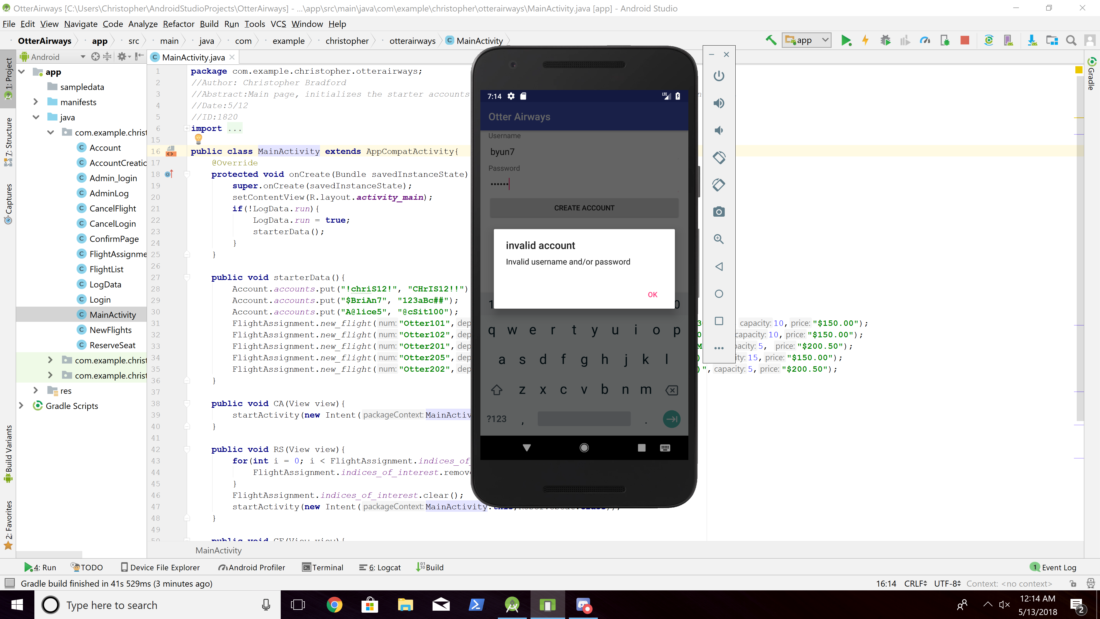

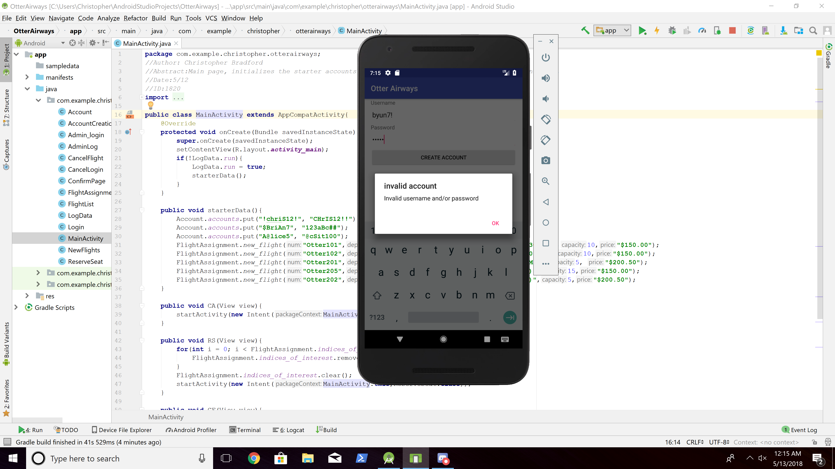

1. Create an incorrect account - Duplicated username

- Select "Create Account"

- Username: $BriAn7

- Password: 123aBc##

🡺 System should display an error message.

- Username: !!Byun7

- Password: !!Byun7

🡺 The system should display an error message again.

The Customer confirms the error message.

Then it displays the main menu.

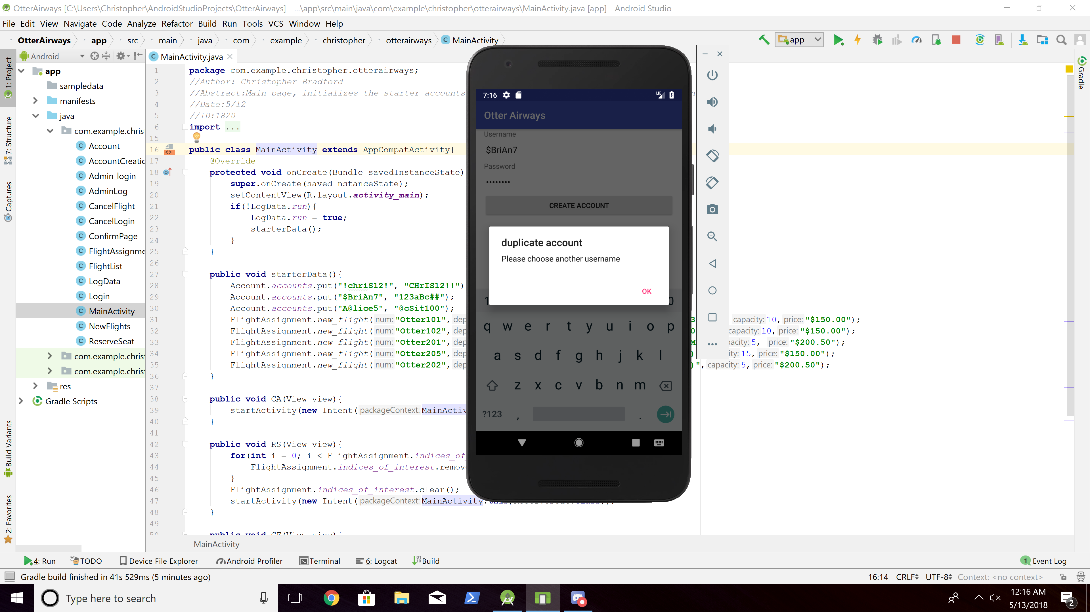

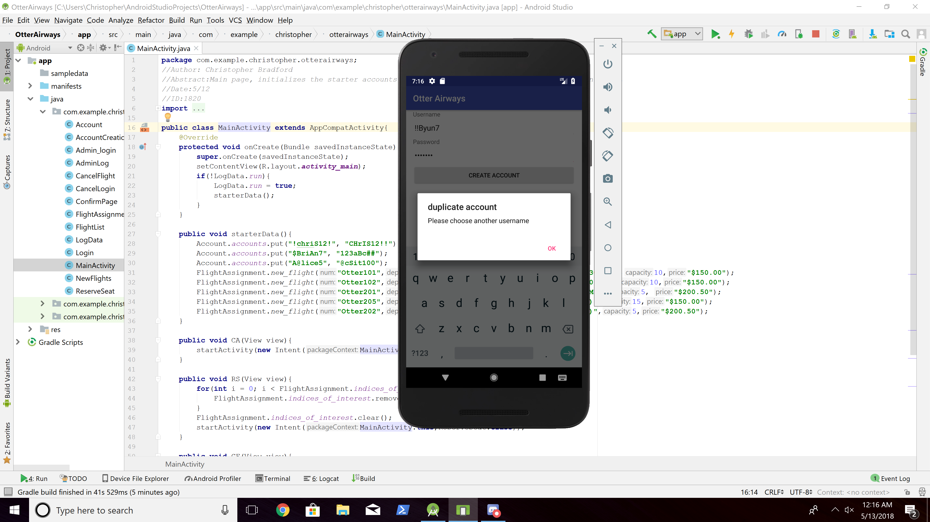

1. Reserve seat

- Select "Reserve Seat"

- Departure: Monterey

- Arrival: Seattle

- Number of tickets: 2

🡺 System should display two possible flights of Otter201 and Otter205

1. The Customer picks Otter201

2. The Customer enters Username: !!Byun7

Password: !!Byun7

3. The System confirms it and displays

- Username: !!Byun7

- Flight number: Otter201

- Departure: Monterey, 11:00(AM)

- Arrival: Seattle

- Number of tickets: 2

- Reservation number: Depending on the test.

- Total amount: $401.00

4. The Customer confirms it

5. The System displays the main menu.

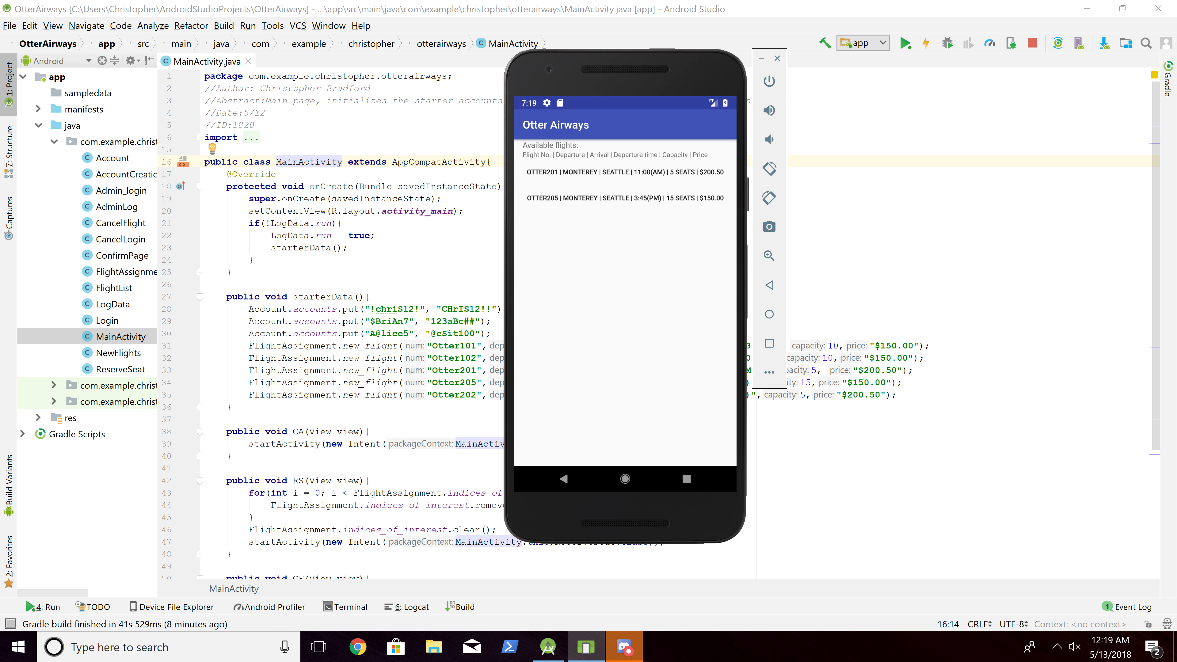

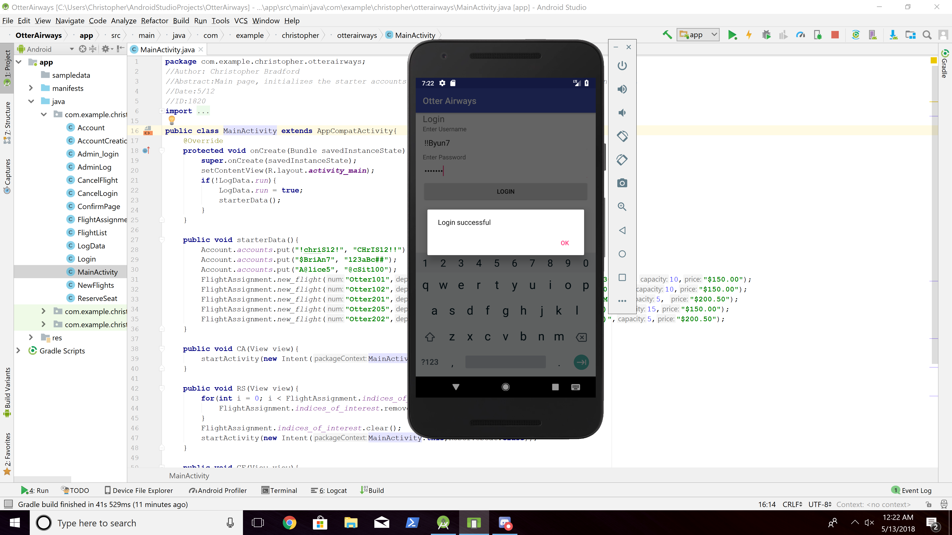

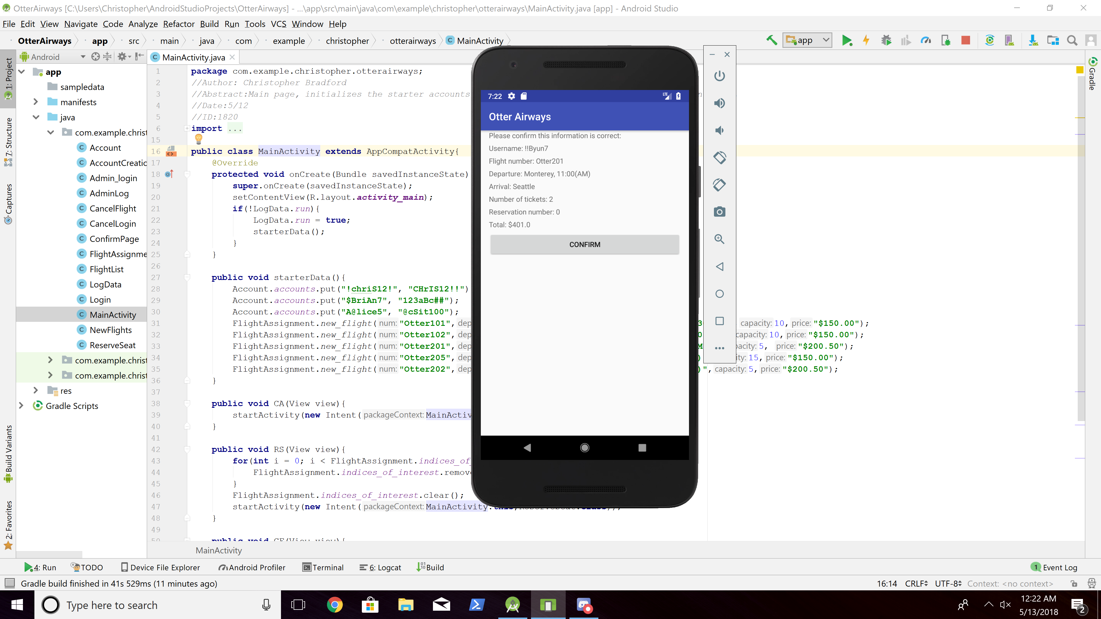

1. Reserve seat - One more trial

- Select "Reserve Seat"

- Departure: Los Angeles

- Arrival: Monterey

- Number of tickets: 6

🡺 System should display one possible flight of Otter102

1. The Customer picks Otter102

2. The Customer enters Username: !!Byun7

Password: !!Byun7

3. The System confirms it and displays

- Username: !!Byun7

- Flight number: Otter102

- Departure: Los Angeles, 1:00(PM)

- Arrival: Monterey

- Number of tickets: 6

- Reservation number: Depending on the test.

- Total amount: $900.00

4. The Customer confirms it

5. The System displays the main menu.

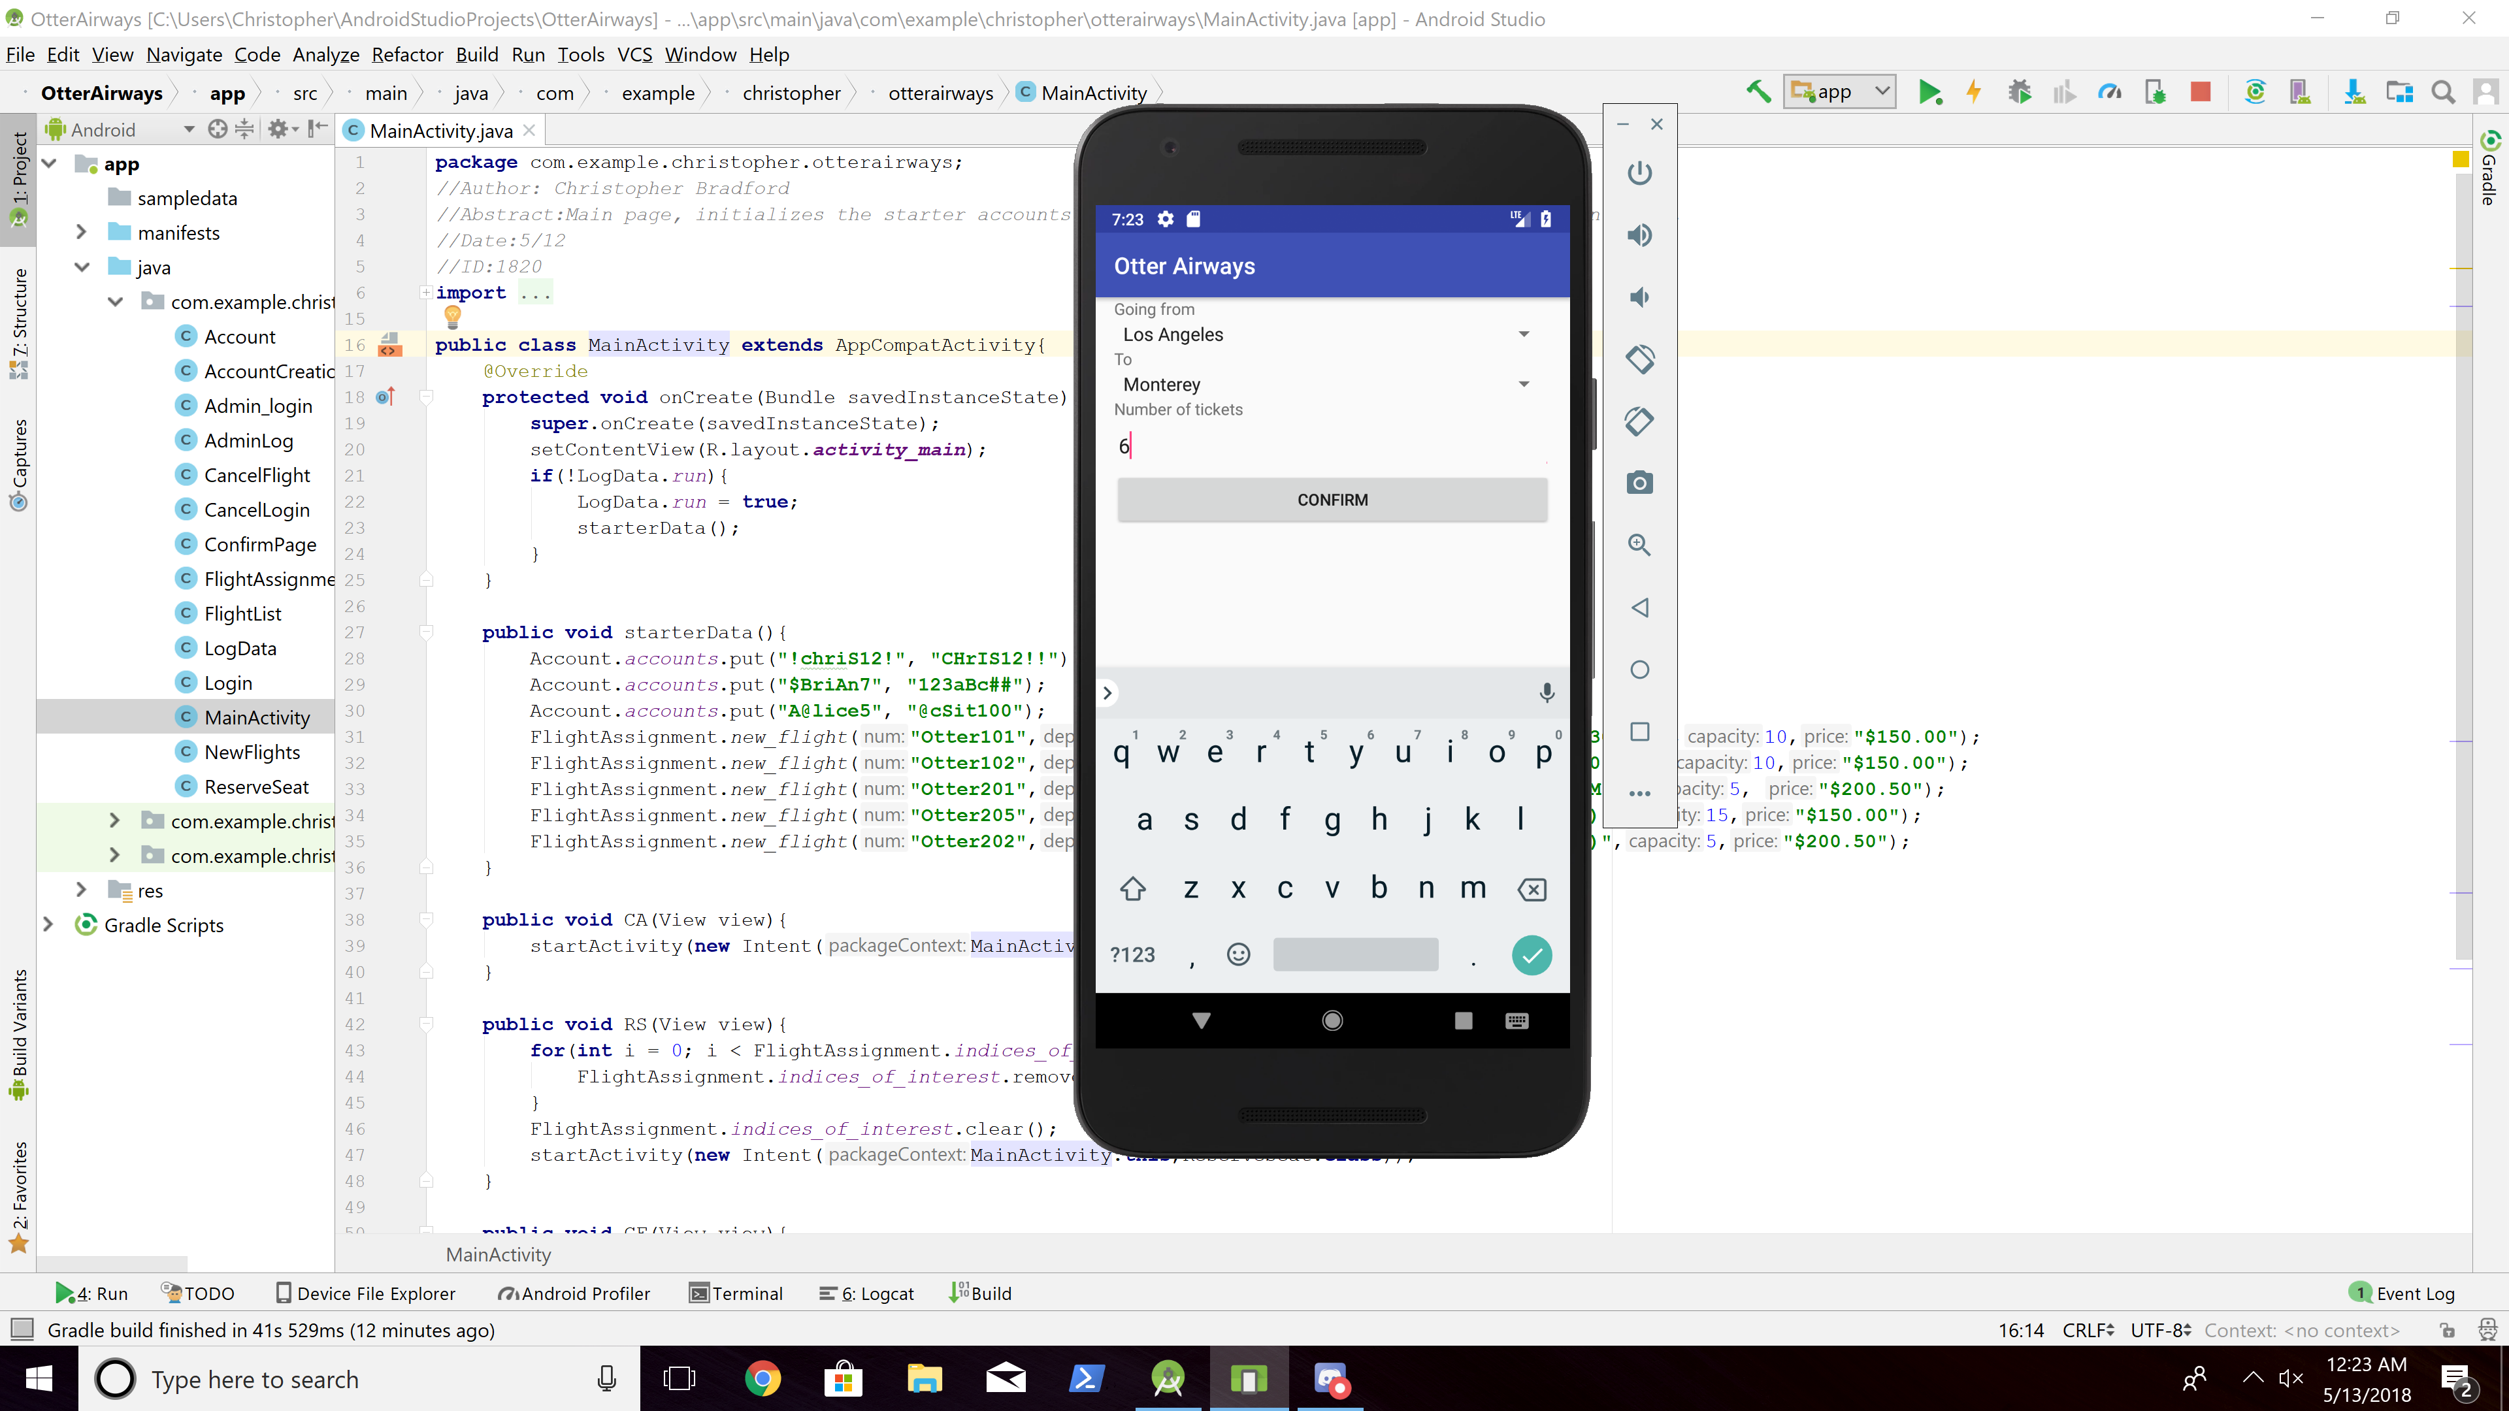

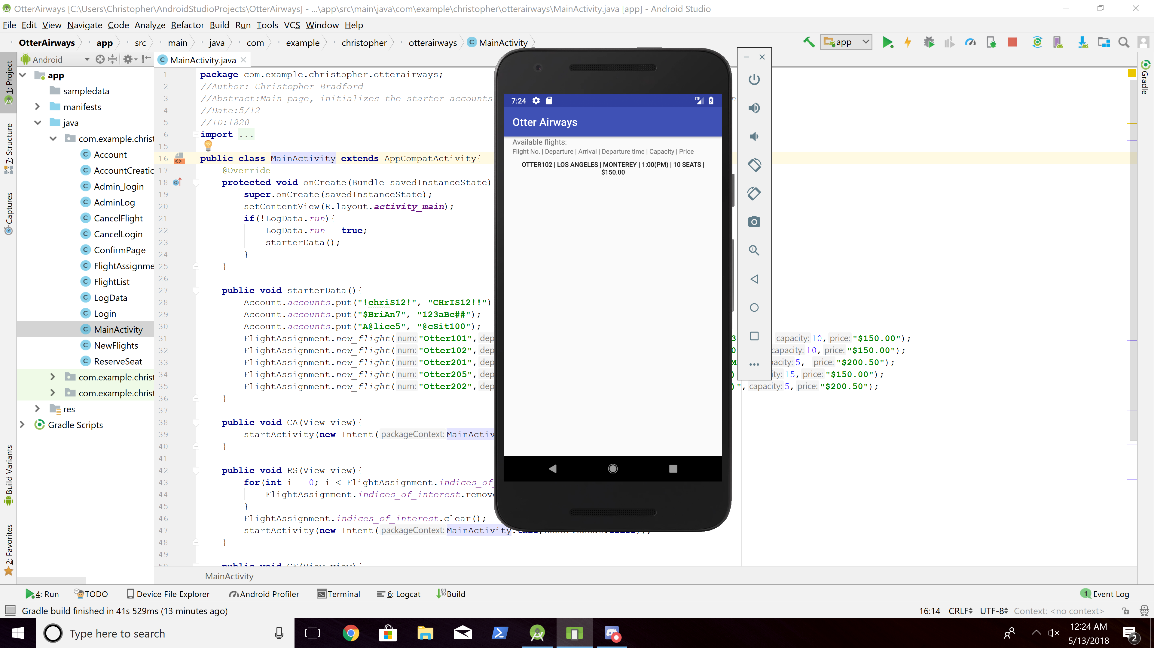

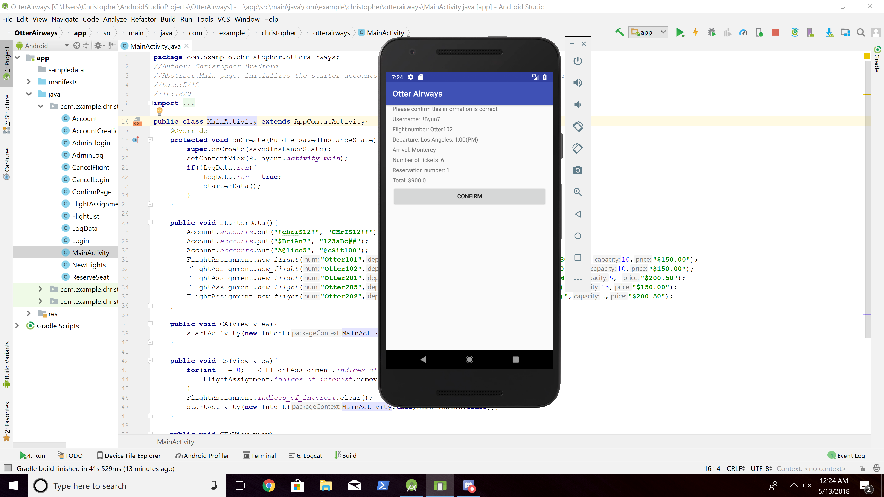

1. Reserve seat - Handle No Seats Available

- Select "Reserve Seat"

- Departure: Monterey

- Arrival: Los Angeles

- Number of tickets: 10

🡺 System should inform the Customer that the reservation can’t be made due to the system restriction.

The Customer confirms the error message.

- Departure: Monterey

- Arrival: Los Angeles

- Number of tickets: 5

🡺 System should display one possible flight of Otter101

1. The Customer picks Otter101

2. The Customer enters Username: !!Byun7

Password: !!Byun7

3. The System confirms it and displays

- Username: !!Byun7

- Flight number: Otter101

- Departure: Monterey, 10:30(AM)

- Arrival: Los Angeles

- Number of tickets: 5

- Reservation number: Depending on the test.

- Total amount: $750.00

4. The Customer confirms it

5. The System displays the main menu.

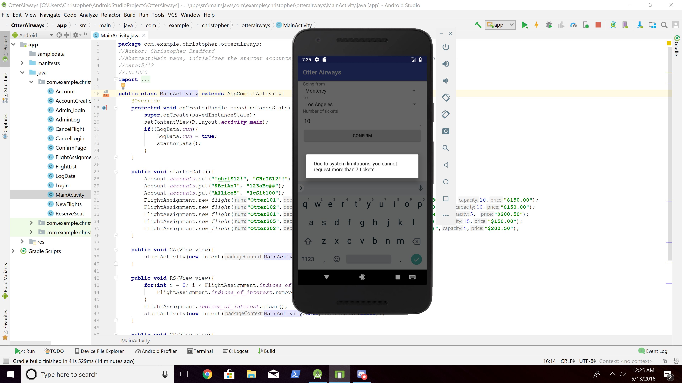

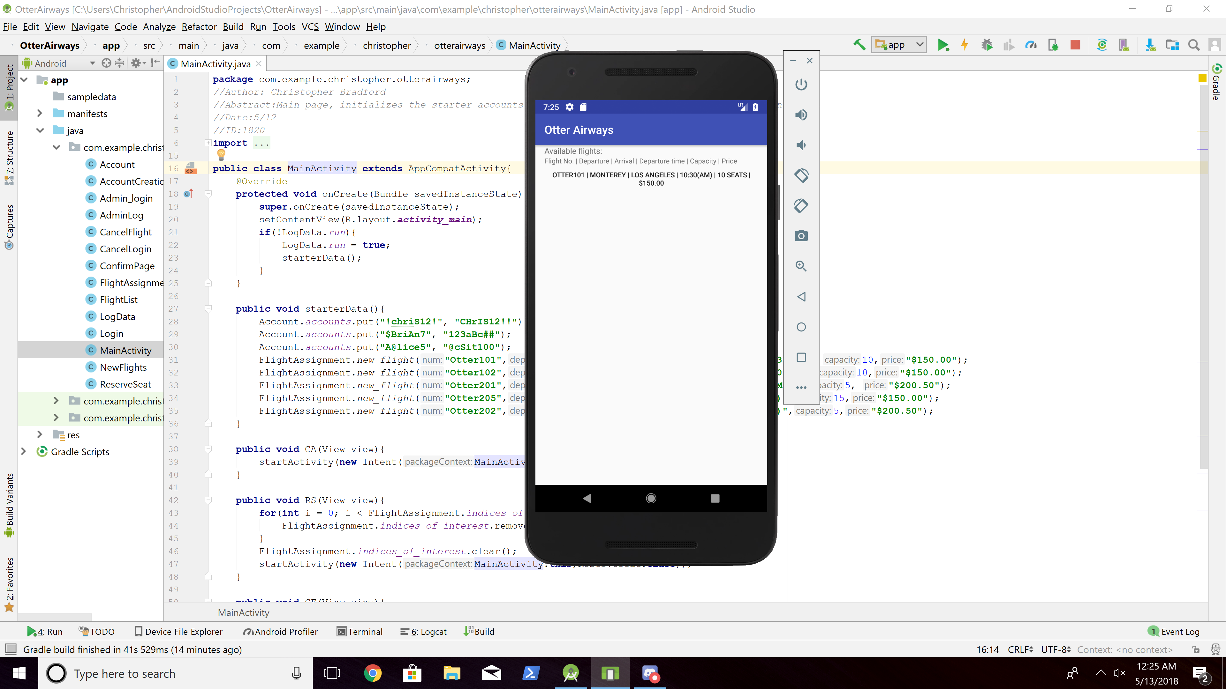

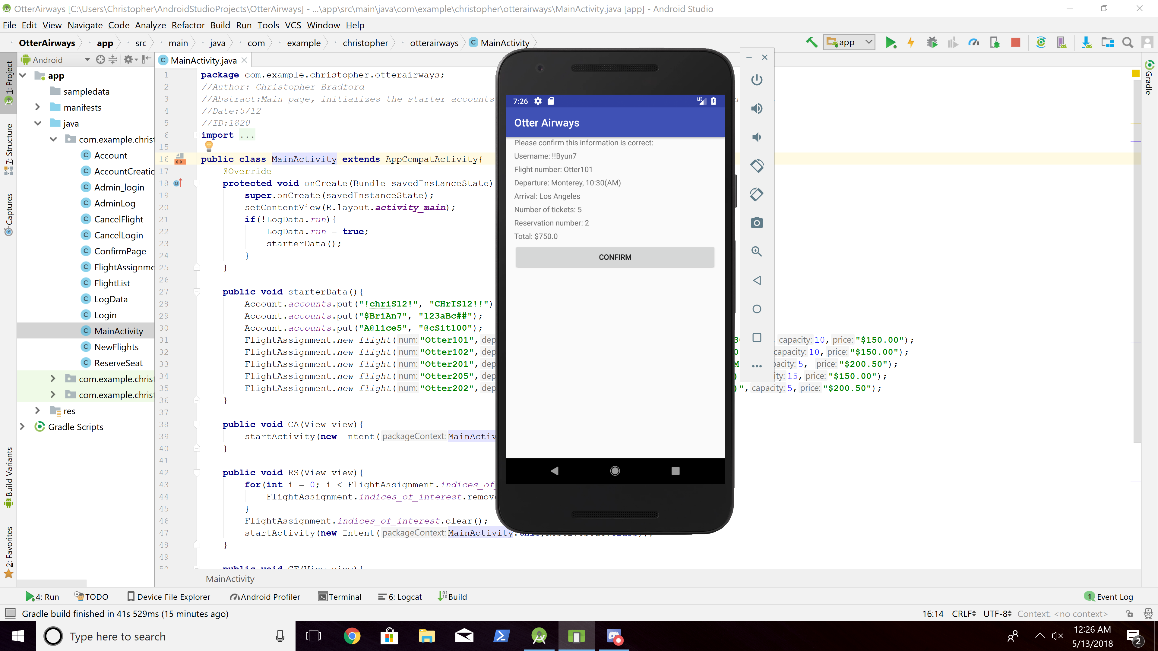

1. Reserve seat - Handle No Flight Available

- Select "Reserve Seat"

- Departure: Seattle

- Arrival: Los Angeles

- Number of tickets: 1

🡺 The System informs the Customer that there is no flight available for the departure/arrival.

The System prompts the Customer to exit the program.

The Customer clicks the “Exit” and the System displays the main menu.

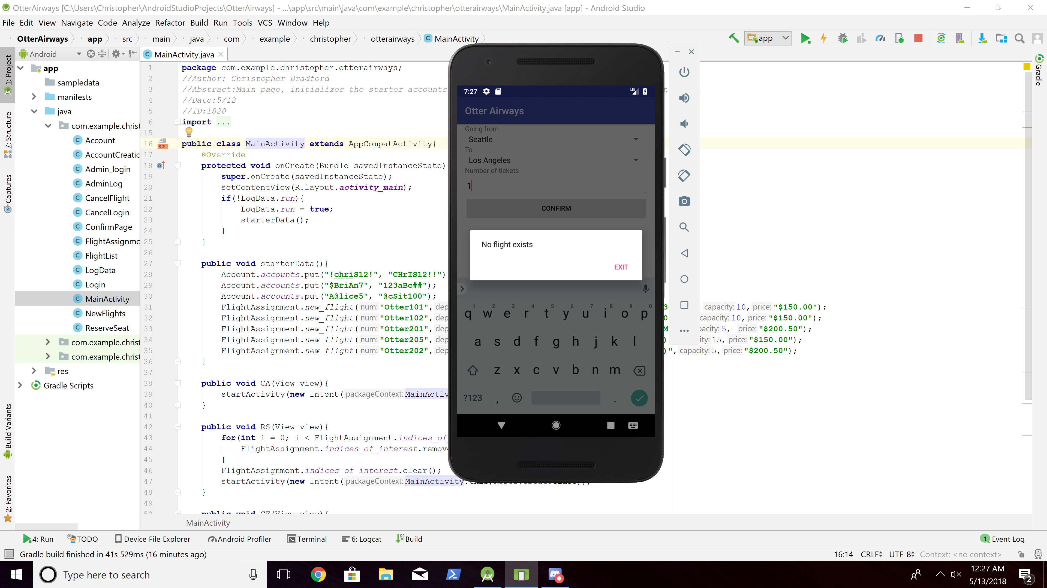

1. Cancel reservation - Handle No Reservation

- Select "Cancel Reservation"

- Username: !chriS12!

- Password: CHrIS12!!

🡺 System should display

1. The System informs the Customer that there is no reservation with the username.

2. The Customer verifies this to continue.

3. The System displays the main menu.

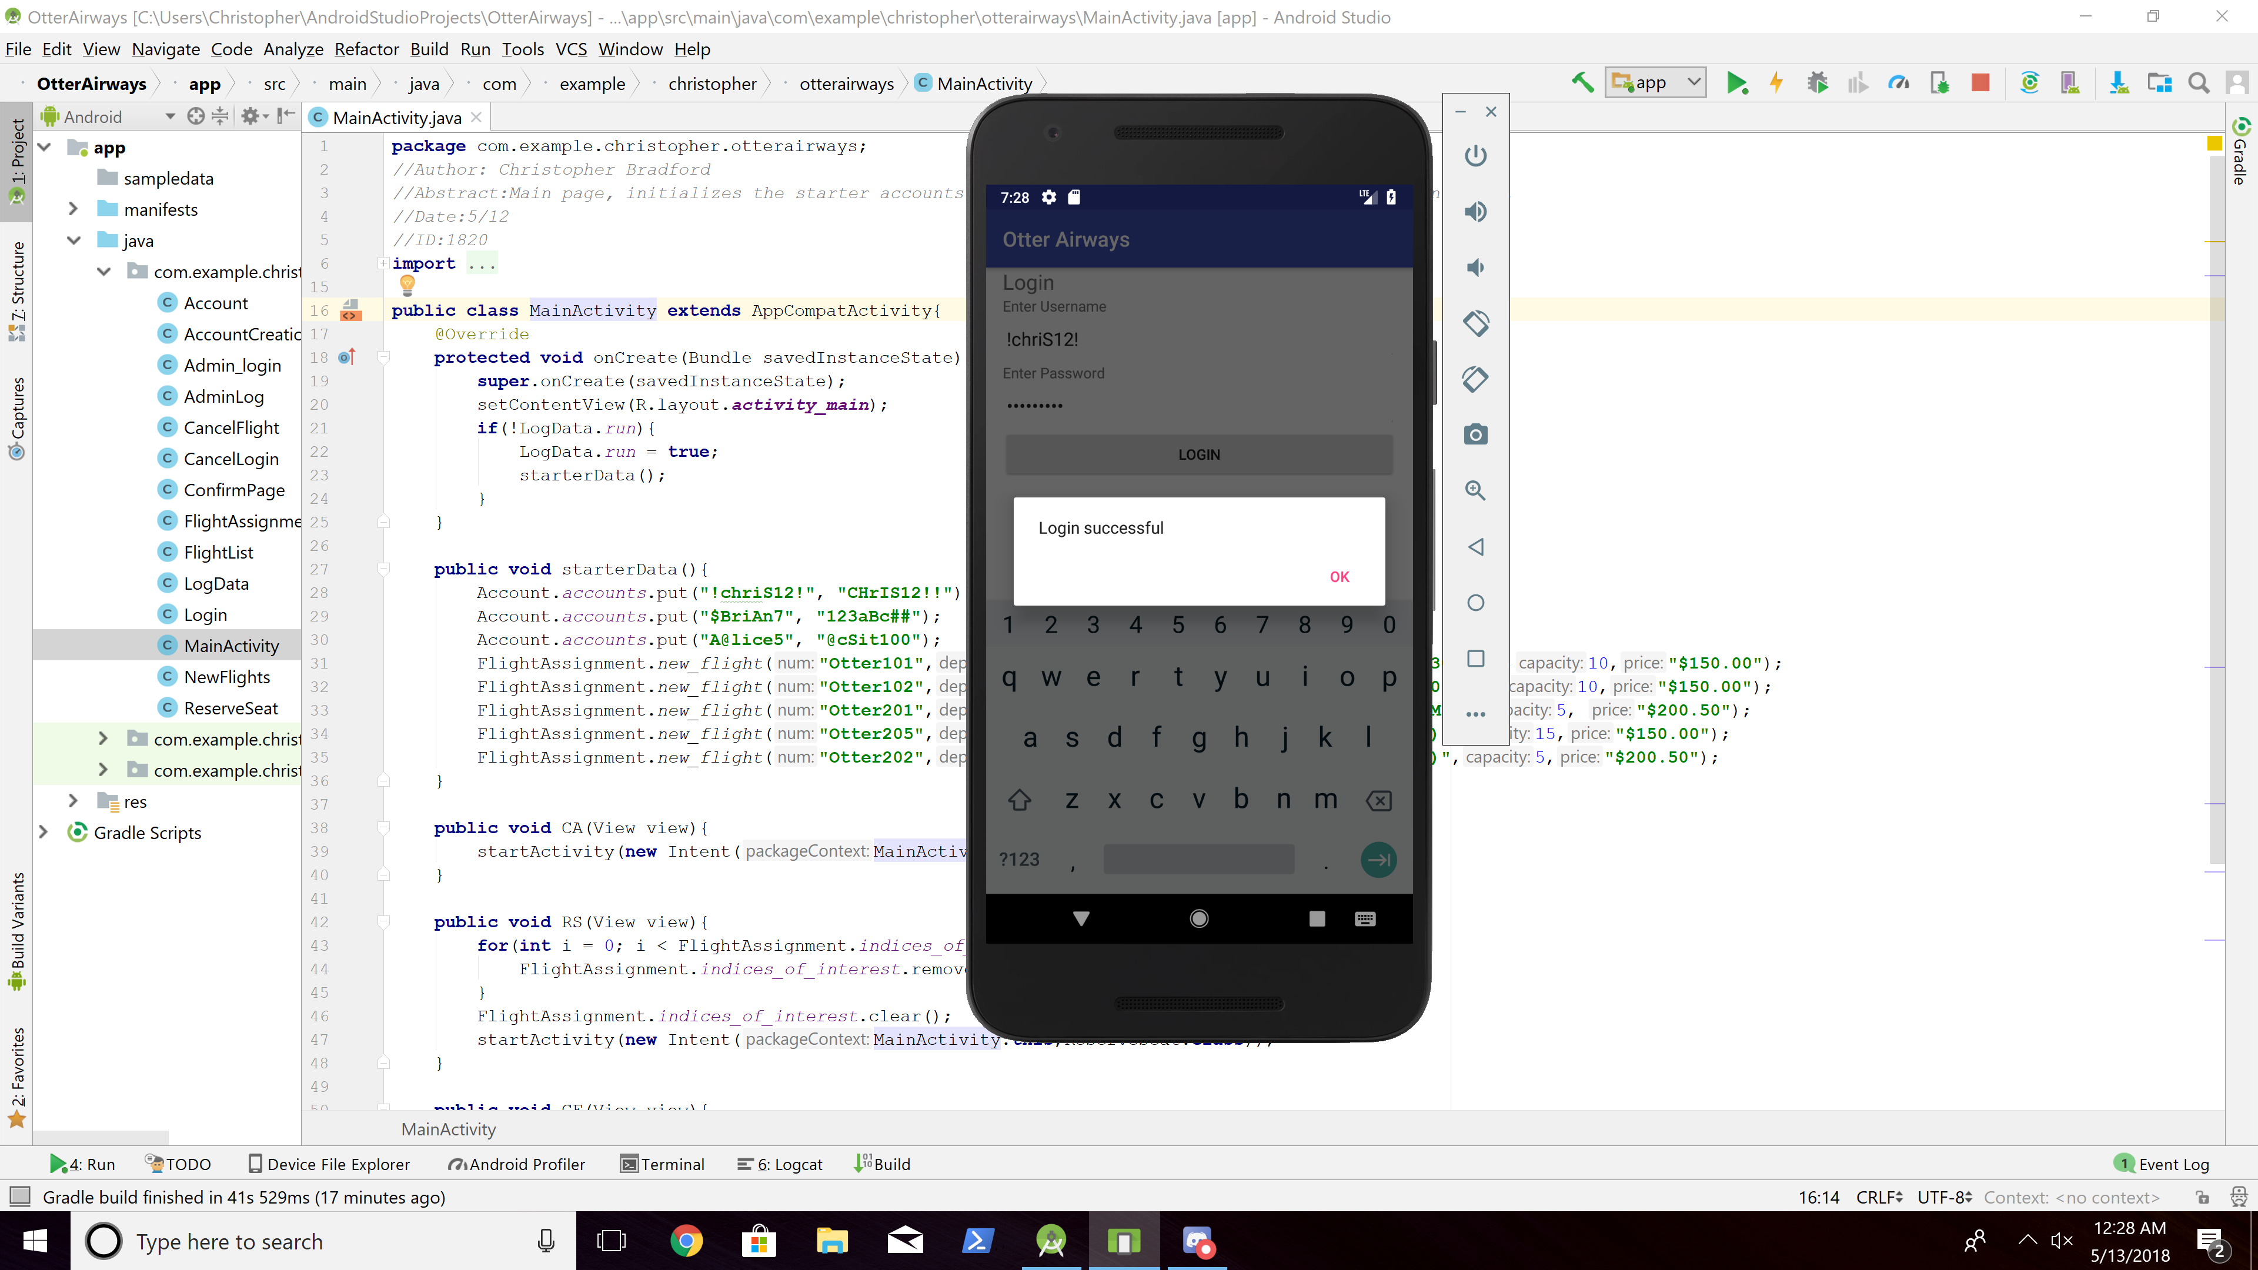

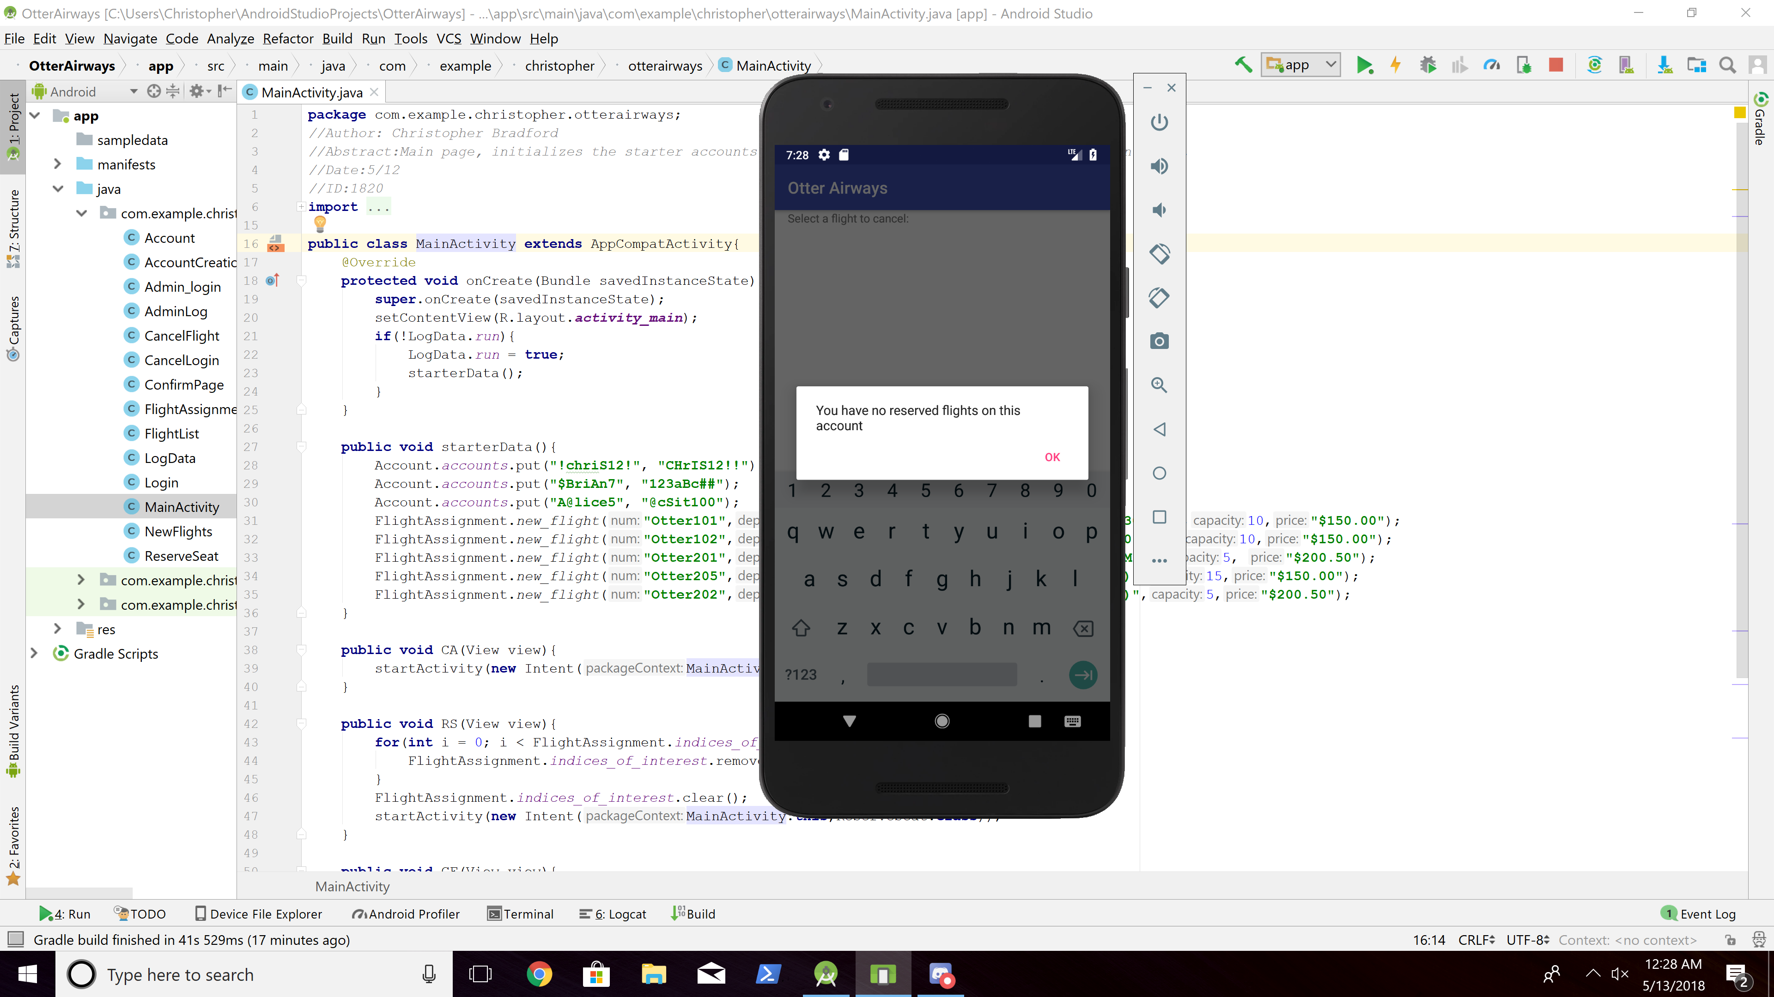

1. Cancel reservation

- Select "Cancel Reservation"

- Username: !!Byun7

- Password: !!Byun7

🡺 System should display

1. All three reservations of “!!Byun7” with the detailed information.

- Select "Otter102" to cancel it.

1. The System requests confirmation and the Customer confirms it.

2. The System should display the main menu.

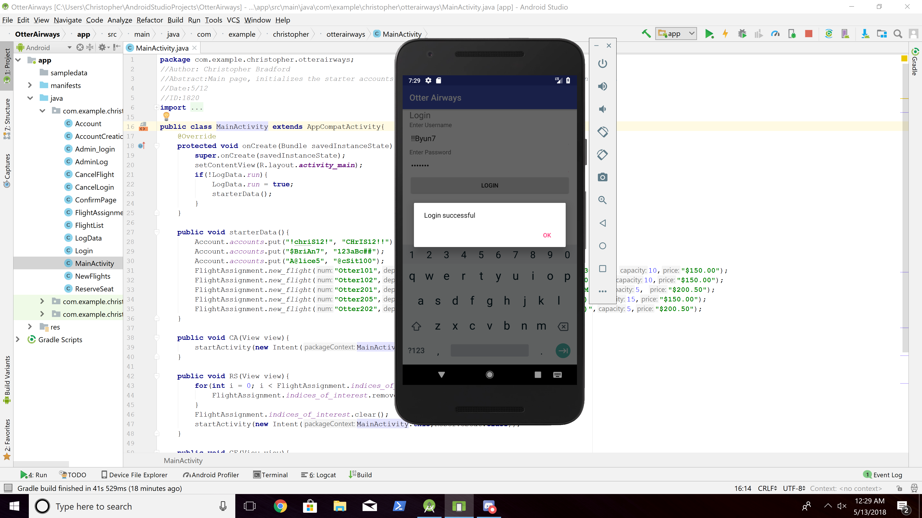

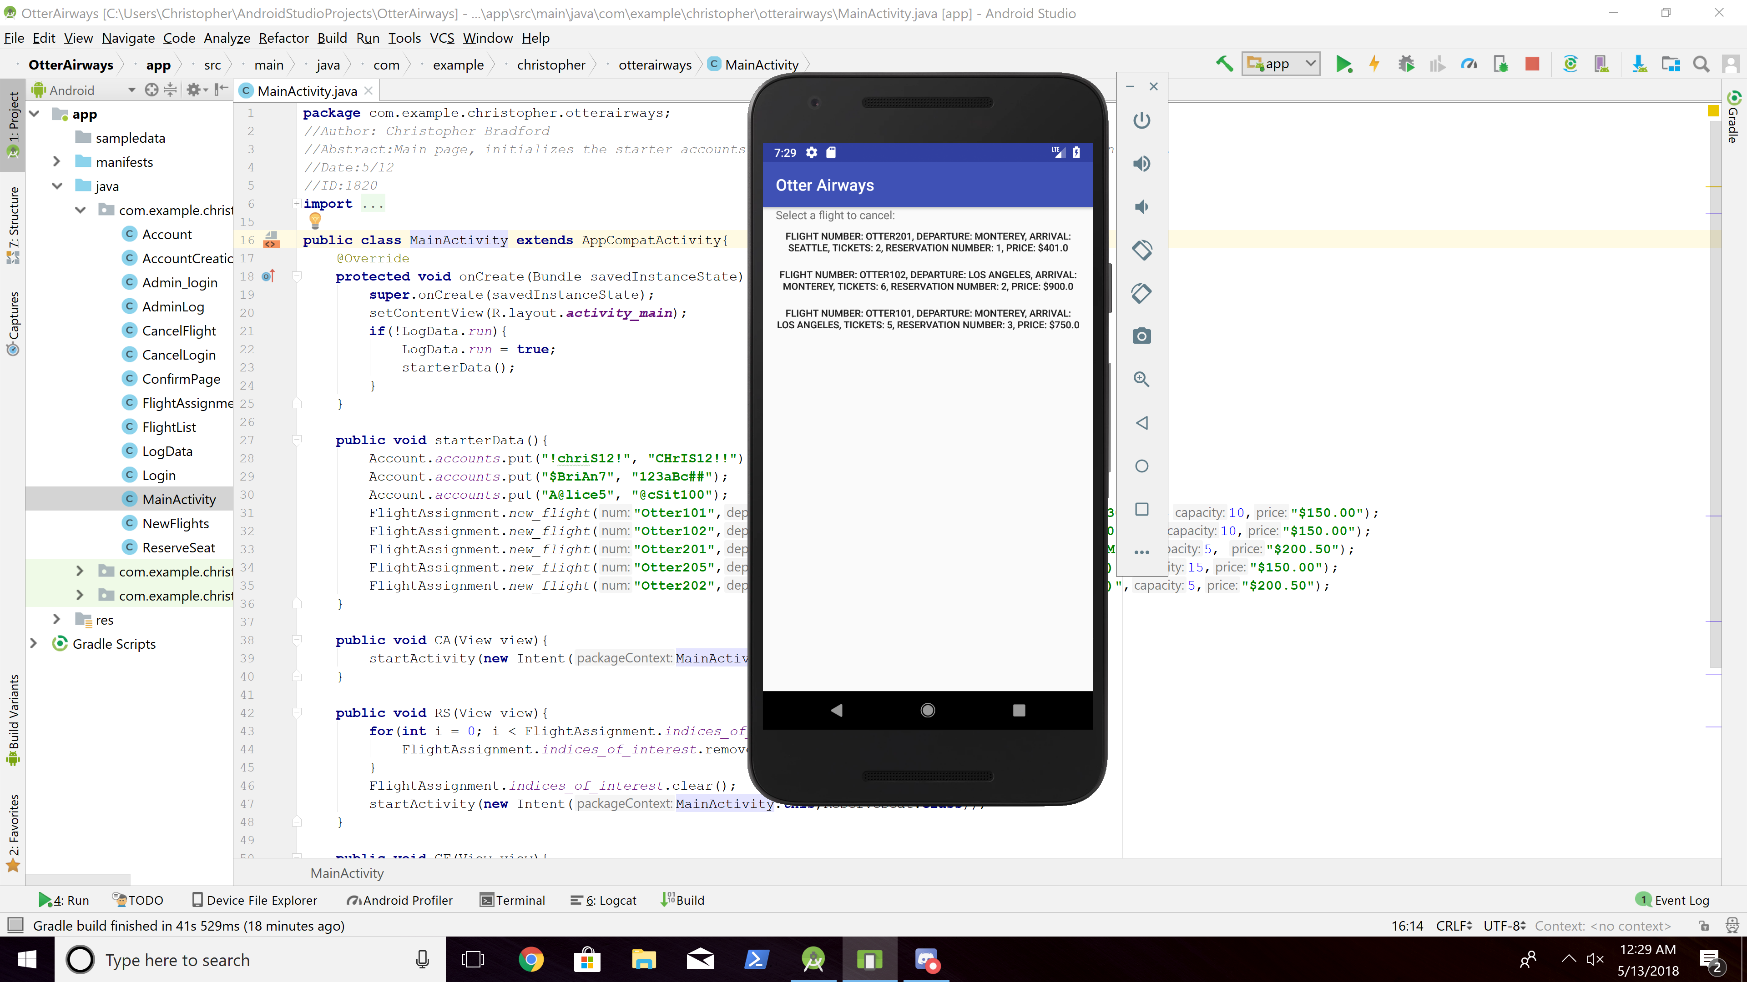

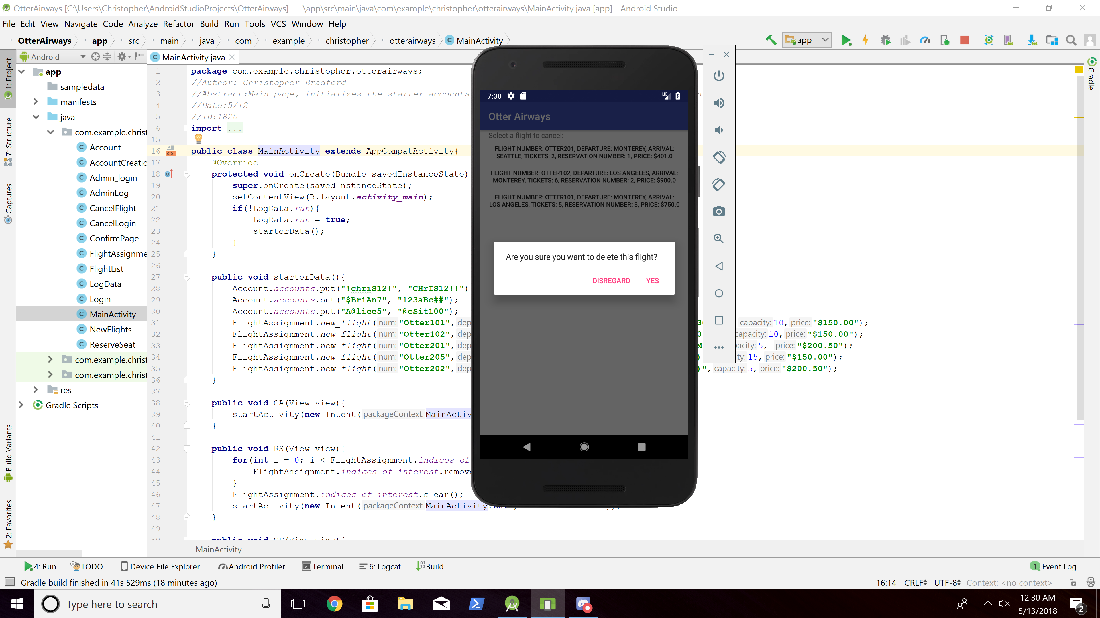

1. Manage the system - Verify the cancellation

- Select "Manage System"

- Username: !admiM2

- Password: !admiM2

🡺 The System should display all transactions so far. But our focus in this test case is the last transaction which should include

1. Transaction type: Cancellation

2. Customer's username: !!Byun7

3. Flight number: Otter102

4. Departure: Los Angeles, 1:00(PM)

5. Arrival: Monterey

6. Number of tickets: 6

7. Reservation number: Depending on the test.

8. Transaction date: Depending on the test case 11 execution date.

9. Transaction time (= hour and minute): Depending on the test case 11 execution time.

- In this test case, the System Operator doesn’t add new flight.

🡺 The System should display the main menu.

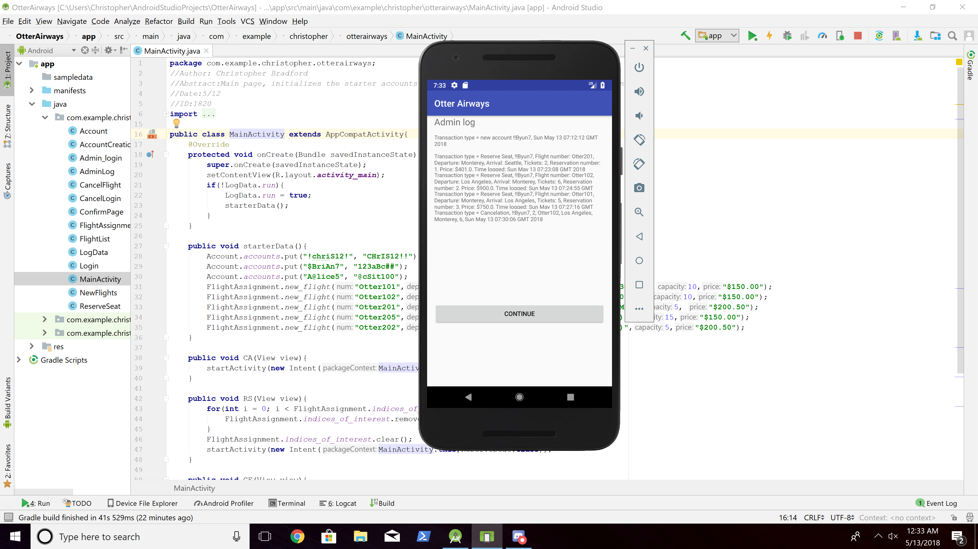

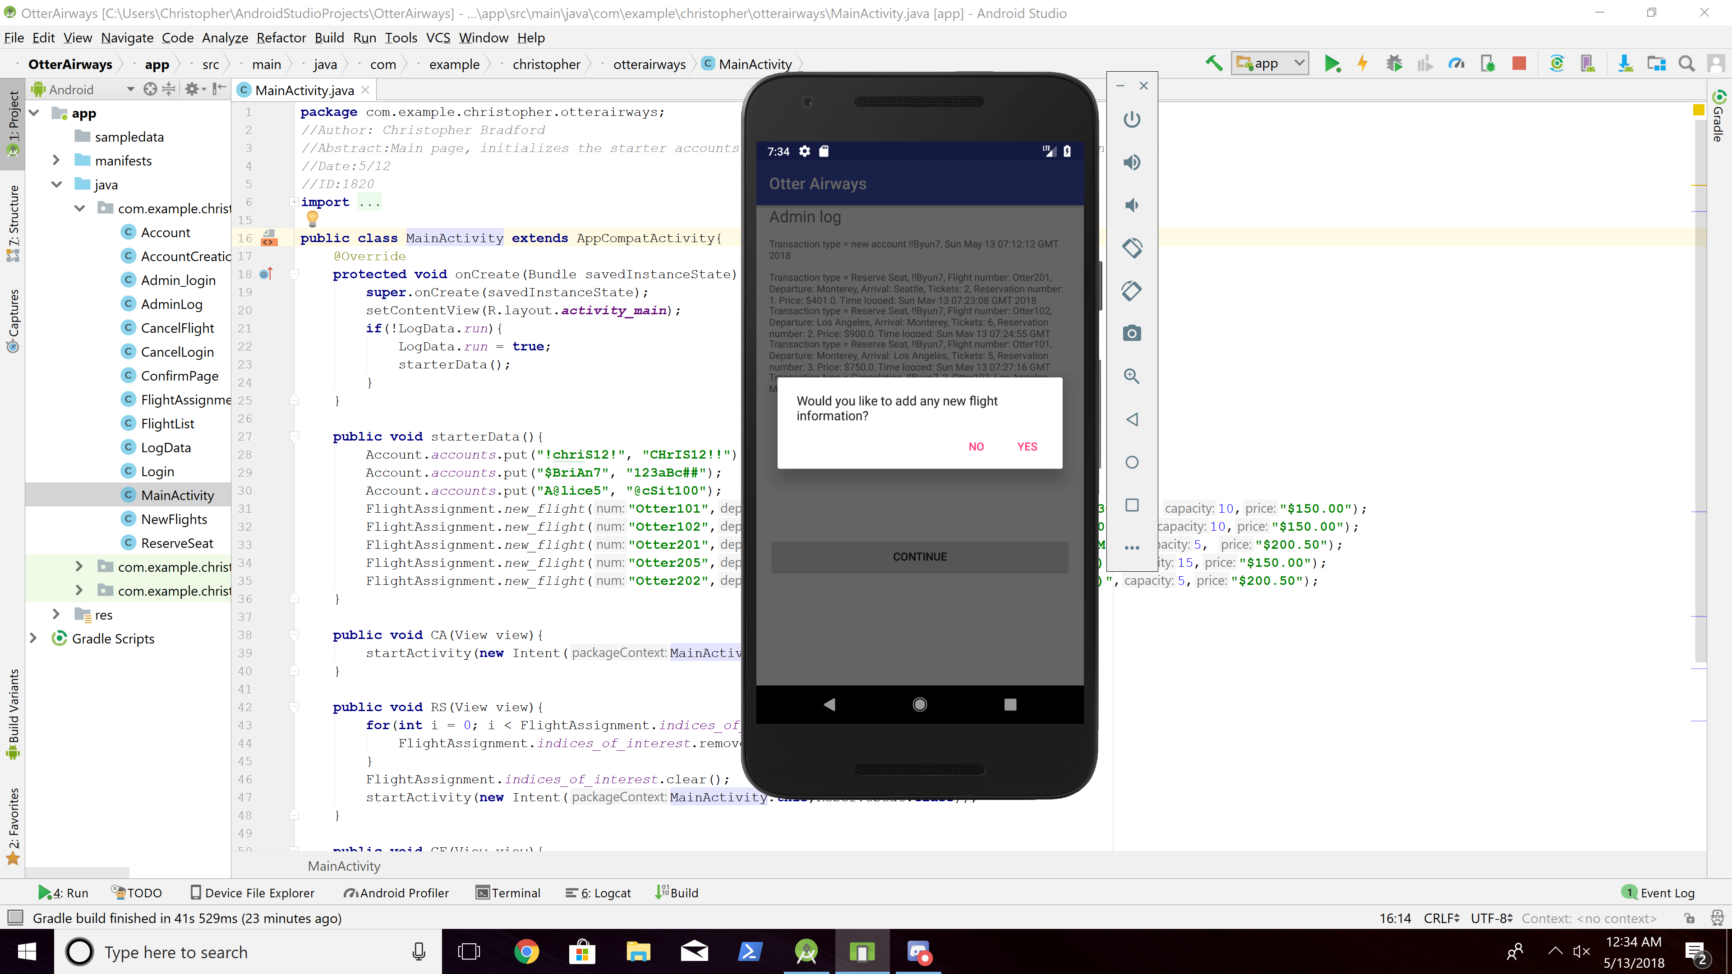

1. Manage the system - Add a new flight

- Select "Manage System"

- Username: !admiM2

- Password: !admiM2

🡺 The System should display logs. But it's not important at this test case.

- The System Operator selects the YES option to add a new flight.

1. Flight number: Otter301

2. Departure: Los Angeles

3. Arrival: Seattle

4. Departure time: 12:00(PM)

5. Flight capacity: 10

6. Price: $350.50

🡺 The System requests confirmation and the System Operator confirms it.

After that, the System should display the main menu.

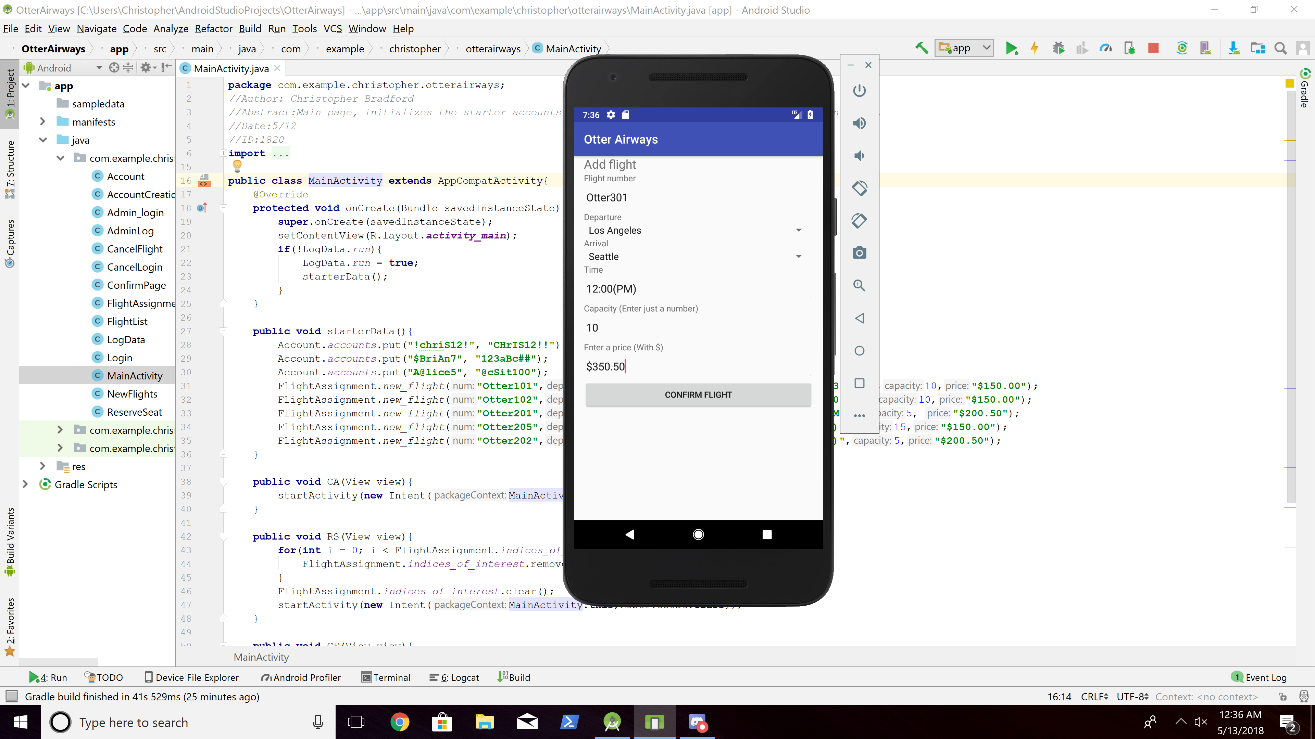

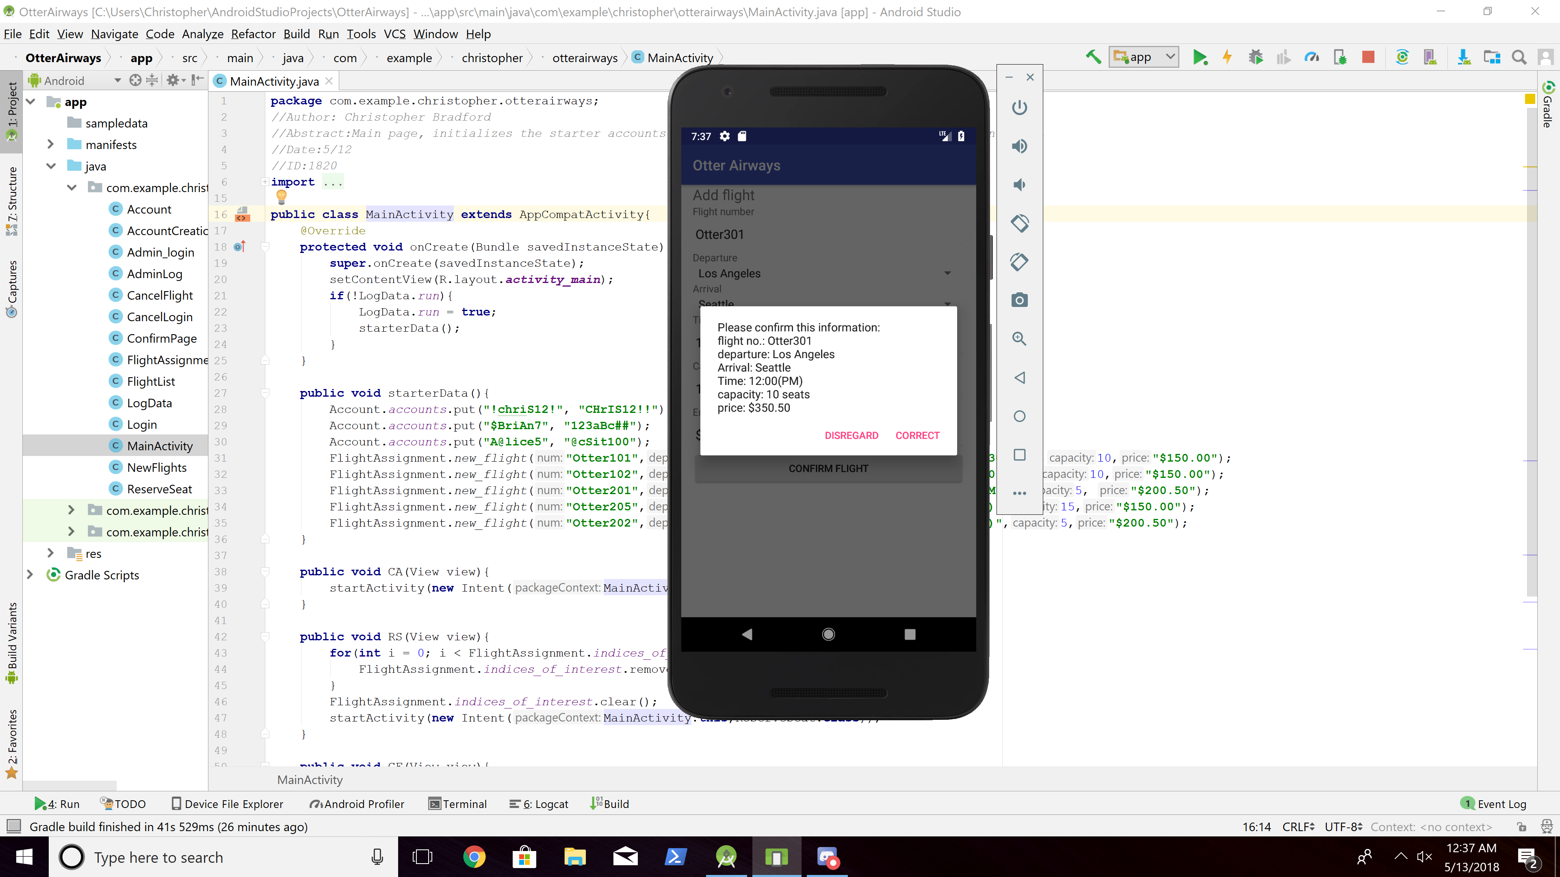

1. Manage the system - Handle Invalid Flight Information

- Select "Manage System"

- Username: !admiM2

- Password: !admiM2

🡺 The system will display logs. But it's not important at this test case.

- The System Operator selects the YES option to add a new flight.

1. Flight number: Otter205

2. Departure: Seattle

3. Arrival: Los Angeles

4. Departure time: 2:00(PM)

5. Flight capacity: 5

6. Price: $300.00

🡺 The System informs the System Operator that the information entered is not valid. In the test case, note that the flight number, Otter205, already exists.

The System Operator confirms the error message and the System should display the main menu.

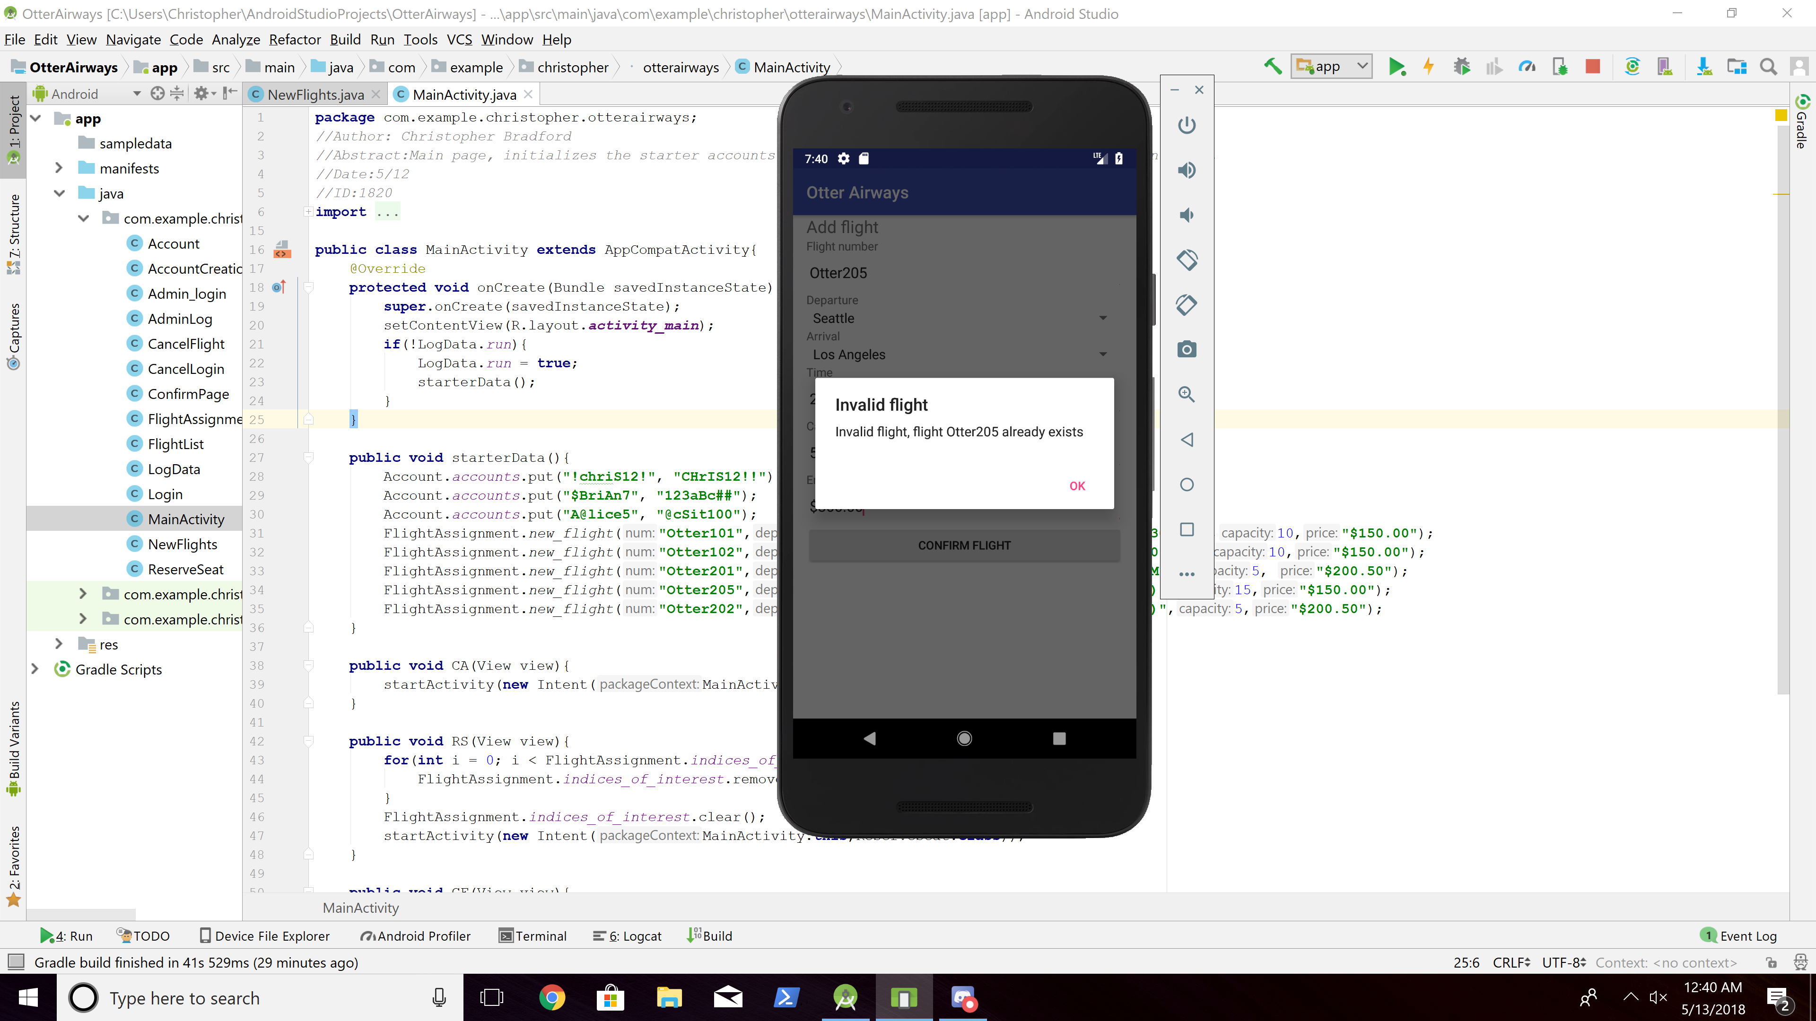

1. Reserve seat - One more trial

- Select "Reserve Seat"

- Departure: Los Angeles

- Arrival: Seattle

- Number of tickets: 1

🡺 System should display one possible flight of Otter301

1. The Customer picks Otter301

2. The Customer enters Username: !!Byun7

Password: !!Byun7

3. The System confirms it and displays

- Username: !!Byun7

- Flight number: Otter301

- Departure: Los Angeles, 12:00(PM)

- Arrival: Seattle

- Number of tickets: 1

- Reservation number: Depend on the test.

- Total amount: $350.50

4. The Customer confirms it

5. The System displays the main menu.

